ISSN – 2349-0683

 | Asian Pacific Journal of Nursing | 
 | Journal homepage: www.mcmed.us/journal/apjn

A RESEARCH ON PROBLEMS OF NURSES - WORK PLACE VIOLENCE IN INDIA

Padma sree Potru^{1*}, Srivani G², Suma Priya D², Swaroopa Rani. Ch.³, Harsha G⁴

¹Nursing Superintendent, Ramesh Hospitals, Guntur, Andhra Pradesh, India.
²Assistant Professor, SIMS College of Nursing, Guntur, Andhra Pradesh, India.
³Nurse Educator, Star hospitals, Hyderabad, Andhra Pradesh, India.
⁴Nursing Officer, CCU, Dr. Ram Manohar Lohia Hospital Post Graduate Institute of Medical Education and Research, Connaught Place, New Delhi, Delhi 110001, India.

ABSTRACT
“Work is Worship”, we struggle for our existence and this should be enjoyable and fulfilling especially in health care organizations nurses and physicians spend long hours with their patients and family members who want quality care. No matter too much of care result into threat like “too much of familiarity brads contempt”. Mostly diverse group of people set up in the health care organization. Hence they need lot of understanding towards their staff and patients because it will affect their behaviors with people in work place. The 2008 international survey revealed that 22 of 1000 nurses are victims of various forms of violence. India is the second largest country in population. Economically it has increased a lot than before. Health care is also growing with it. Even violence is also increasing with this. Even it has become very common is health care organizations. Nurses are significant population in hospitals. They play vital role in the lives of the patients. Their presence in stressful situations such as accidents, death, waiting to visit a doctor or transfer of patient towards etc. They face a lot of abuses from the patients, like harsh behavior and physical violence. Whereas in private there was significant association with religion (χ²=22.189, p=0.008), educational level (χ²=25.751, p=0.002) (21) having a bachelors degree or higher in nursing was associated with a decreased likelihood of reporting abuse. Significant association was found with designation (χ²=34.517, p=0.011), type of employment (χ²=44.717, p=0.00) and experience (χ²=28.34, p=0.00). This reveals less education level, lower designation, temporarily employed nurses are more prone for Work Place Violence. As lateral violence is most commonly seen in this study senior nurses abuse the nurses who are temporary as they cant retart against them, their subordinates who usually will be submissive. Less experience nurses fear more and they are prone for Work Place Violence when compared to experience nurses as they know how to handle the situation and what to do against violence at work place. The study concluded that both the respondent nurses experienced mild work place violence. The major perpetrators of work place violence were patient and patient relatives. It is because of the illness in the family they become aggressive and get depressed as the prognosis of the disease was in dilemma. The common emotions experienced by the nurses are sadness, anger and disappointment. The lateral violence and work place violence can be reduced by the development and implementation of specific policies, procedures and staff education programmes. Measures to protect the nurses includes the use of onsite security personnel’s, police officers, and surveillance cameras. Comprehensive work place violence prevention plans should be implemented and evaluated in every department.

Key words: Nurses problems, work place violence, work is worship, nursing staff.

Corresponding Author  Padma sree Potru  Email:- | Article Info  Received 12/03/2019; Revised 20/04/2019  Accepted 04/05/2019

INTRODUCTION
“Work is Worship”, we struggle for our existence and this should be enjoyable and fulfilling especially in health care organizations nurses and physicians spend long hours with their patients and family members who want quality care. No matter too much of care result into threat like “too much of familiarity brads contempt”. Mostly diverse group of people set up in the health care organization. Hence they need lot of understanding towards their staff and patients because it will affect their behaviors with people in work place. The 2008 international survey revealed that 22 of 1000 nurses are victims of various forms of violence.
India is the second largest country in population. Economically it has increased a lot than before. Health care is also growing with it. Even violence is also increasing with this. Even it has become very common is health care organizations. Nurses are significant population in hospitals. They play vital role in the lives of the patients. Their presence in stressful situations such as accidents, death, waiting to visit a doctor or transfer of patient towards etc. They face a lot of abuses from the patients, like harsh behavior and physical violence. These should be controlled by the authorities. The common types of violence experienced by nurses are physical, emotional, sexual and horizontal violence. The major areas of bullying and work place violence is in medical wards, ICU and emergency wards. The lowest is noted in maternal, child, psychiatric and operation theaters.
Violence like physical and verbal, both have its effect like physical injuries, deaths of workers etc., [1,2]. The rate of physical violence committed against physicians was 16.2 per 1000 workers where as against nurses it was 21.9 per 1000 workers. Verbal abuse is the most commonest type of violence experienced by nurses. Verbal abuse towards nurses is a major concern. The research studies shows 80% of nurses experienced verbal aggression and the sources are nurses, physicians, patient families and patients. The Common verbal threats are abuse includes warning, using offensive language.
The differences in the power resulted in two groups. Superior and subordinate groups which is leading to ‘horizontal violence’. The subordinate group feelings are inferior and acted out, the feelings of hate on one another and conflicts are developed. Verbal abuse is defined as an act that is intended to humiliate or disrespect an individual’s feelings, emotionally hurt or personally/ professionally attacked which results in less productivity[3]. The measures are to be taken in work places, to decrease the risk of Work Place Violence against workers in Health care settings. The worker’s gender, age, years of experience, hours worked, material status, previous work place violence training have impact on Work Place Violence [4].
Libbus M.K, KG Bowman et.al., (1994) conducted a study to assess the sexual harassment of female registered nurses in hospital. It resulted and reveled that sexual harassment was more frequent in nurses of age group 20-29 years (62-96%) and is unmarried (59.25%) physicians were the foremost perpetrators (37.03%) followed by patient relatives (25.93%). These problems can affect the work performance and productivity in hospital. Health care providers are facing high risk of workplace abuse that can result in variety of negative outcomes like anger, fear, depression, anxiety sleep disruption, increased sick leave, symptoms of posttraumatic disorders and job dissatisfaction. In addition nurses are trying to leave their jobs[5].
There will be physical effects like irritable bowel syndrome, migraines, hypertension, allergies, asthma, arthritis, decreased immune system response and cardiac arrhythmia, which increase the risk of myocardial infarction. Emotional effects like poor concentration, low self esteem, intention to leave the job, fear of supervisor’s criticism, loss of confidence, changes in relationships with co-workers, forgetfulness, loss of sleep, increased fatigue, indecisiveness, nightmares, obsessive thinking the bully, excessive drinking of alcohol, drug taking and over eating to cope with the anxiety and panic that occurs that results in premature death, suicide, homicide, etc. Many victims suffer from relationship losses with spouses and colleagues [6]. Due to these problems, nurses are feeling inferior and insecured and they need support from society and organization they work for. Research shows that work place violence is noted more where organization and superior supports is less. The institutions should identify the risk factors and prevalence of work place violence like increased number of chronic and acute mentally ill patients, presents of more gang members, lack of staffing, poor lighting parking areas, isolated work areas and necessary actions to be taken to prevent the violent incidents. The organizations suffer from decreased productivity, low employee morale, job stress, absenteeism, recruitment challenges as the consequences of work place violence.

NEED AND OBJECTIVES OF THE STUDY:
The main aim of the study is to identify the various psychosomatic and social problems among Nurses.
Every year nearly 35 million health care workers are exposed to risk of needle stick or sharp injuries In India on an average 3-6 million injections are administered annually of which 1/3 injections are unsafe due to usage of glass syringes and associated risks of infection. As physical activities are concerned after industrial jobs nursing is in 2nd rank in which work related musculoskeletal problems occur with high prevalence. Though nurses have ascended the steps of prestige ranking on the professional ladder, public opinion ranks them 3rd position, next to engineers and physicians. Continuous treatment of violence leading to mental health problems among nurses, which in turn affect the work output. The personal and professional problems are affecting them with very poor life satisfaction. The other problems like low status, long working hours risk for infections, questions regarding sexual purity, their family background, low socio economic status, work load, less importance in organizations, decision making activities are some of them.
After extensive review of literature as many researchers did not peep into all these nurses problems though they are triggering factors. Keeping these aspects in the view the researcher felt that there is a quick need to study the various aspects of Psychosomatic and Social problem among nurses.

OBJECTIVES:
- To study the Socio, Economic and Demographic profile of respondent nurses.
- To identify the incidence of somatic problems like work place violence problems among respondent nurses.
- To undertake 20 case studies for deeper understanding of the specific problems of Nurses.

STUDY DESIGN :
In the present study two settings were selected. Setting-I is Government General Hospital, Guntur which contains 1177 beds and 342 Registered Nurses working in three shifts.
Setting-II is Private Hospital, NRI General Hospital of 1000 beds capacity consist of 510 Registered Nurses working in three shifts.

STUDY POPULATION:
Population refers to the entire aggregation of cases that meets the design criteria[7]. Population consists of the entire set of individual’s events, places or objects that possess the specific characteristics or attributes being studied. In this research two population were described.

SAMPLE SIZE:
Sample size is normally decided by nature of the study, nature of population, type of sampling technique, total variable, statistical test adopted for data analysis, statistical measures & attrition.
In this present study a random sample of 300 Registered Nurses of Government and Private 150 each who are working in different clinical settings were included in the study. The RN_{s} are from Government General Hospital, NRI General Hospital, Guntur, Andhra Pradesh State.

Inclusive Criteria:
- Nurses working in selected Government and Private hospital of Guntur.
- Nurses who are able to understand and read English.
- Registered Nurses only.
- Nurses who are not attended for the training programme related to variables.

Exclusive Criteria:
- Nurses who were not willing to participate in the study.
- Nurses who are working in other settings.
- Nurses who are not available during the period of data collection.

PLAN OF DATA ANLYSIS:
The statistical package for social science (SPSS, Version 18.0) was used for data analysis; the Demographic Data is expressed as frequency, percentages, means and standard deviation. ANOVA was used to co-relate among Work Place Violence, nurses’ view of Public Perception of Nursing, Profession, Job Satisfaction & Life Satisfaction ‘t’ test was used to test the difference between two groups. The chi-square test was used to determine any association between the Demographic and Research variables. All tests were done 0.05 level of significance.

RESULTS:
Violence is a most common, complex and persistent problem faced by nurses. Reasons for violence among nurses are due to the working environment (shift duties) and availability of nurses at patient bed side. Violence is defined as an aggressive behavior “Aimed at inflecting harm or discomfort on its victims”. They are commonly exposed to violence by patient while providing care, patient relatives when patient is not progressing with the treatment and care or when they are not satisfied with hospital facilities, non- availability of doctors, by coworkers due to work pressure or emergencies, lack of understanding, communication gaps, by a doctor due to egos, superiority, low status job, lack of knowledge. Beating, verbal abuse, stabbing, and harassments this can be physical or sexual. When a nurse encounters such kind of violence in her career produces symptoms like acute stress, decreased productivity of work, mental trauma, depression, quitting the job, sometimes it may leads to death due to severe mental trauma due to the Violence at work place nurses are feeling inferior and in secured.
In the current study this section deals with a comparative analysis and interpretation of violence among nurses of Government and Private hospital. The researcher intended to identify the extent of work place violence, types of work place violence, emotional experiences, coping methods, actions taken by self, the employers support towards incident, extent of nurse’s satisfaction with employer’s support and association with demographic variables were assessed and arranged in the following tables.
The above Table 1 reveals that majority of Government 97 (64.7%) and Private 79 (52.7%) nurses were experiencing mild workplace violence, secondly Government nurses 29 (19.3%) were experiencing moderate workplace. Whereas 46 (30.7%) of private nurses were not experiencing any work place violence. However 22 (14.7%) of Government nurses were experiencing no violence and 16(10.6%) of private nurses were experiencing moderate violence. Lastly the least number of Government 2(1.3%) and 9(6%) of private nurses were experiencing severe work place violence.
The table concluded that majority 97 (64.7%) of Government nurses were experiencing more Work Place Violence than private nurses and least 2 (1.3%), 9 (6%) of respondent nurses experienced sever Work Place Violence.
The above Table 3 depicts the percentage distribution of physical assault of the respondent nurses. Majority of Government nurses 55 (36.6%) experienced physical assault from patients whereas 49 (32.6%) of private nurses experienced physical assault from nurses. More over the Government nurses 38 (25.3%) experienced physical assault from patient relatives. Whereas 47 (31.3%), 47 (31.3%) of private nurses experienced physical assault from patient and patient relatives respectively. However, 20 (13.3%) of Government nurses experienced physical assault from doctors whereas 33 (22%) of private nurses experienced physical assault from class IV employees. Lastly, 5 (3.3%), 5 (3.3%), 4 (2.6%) of Government nurses experienced physical assault from class IV employees, other type of physical assault and nurses respectively whereas 16 (10.6%) of private nurses experienced physical assault from doctors. To conclude most of the Government nurses 55 (36.6%) experienced physical assault from patients. Whereas for private nurses 49 (32.6%) experienced physical assault from nurses.
The above Table 4 reveals percentage distribution of verbal abuse of respondent nurses. Majority of Government and private nurses 57 (38%) experienced verbal abuse from patient relatives. Further Government nurses and private nurses of 53 (35.3%) experienced verbal abuse from doctors, patients and nurses respectively. However, 51 (34%) of private nurses experienced verbal abuse from class IV employees. Moreover 36 (24%) of Government employees experienced verbal abuse from patients whereas 25 (16.6%) of private nurse experienced verbal abuse from doctors. Government nurses 17 (11.3%) experienced verbal abuse from Nurse. Lastly 3 (2%), 1(0.7%) of Government nurses experienced verbal abuse class IV employees and also other type of verbal abuse respectively. 2 (1.33%) of private nurses experienced verbal abuse from others.
To conclude, that the highest percentage 57 (38%) of Government and private nurses experienced verbal abuse from patient relatives and the least is from others.
The above Table 5 represents the percentage distribution of verbal threat of the respondent nurses. Majority of Government nurses experienced verbal threat from others 40(26.6%) where as private nurses experienced verbal threat from nurses 38(25.3%). Further more Government nurses experienced verbal threat from patient relatives 27 (18%). Whereas 28(18.6%) of private nurses experienced verbal threat from class IV employees. Moreover, 24(16%) of private nurses experienced verbal threat from patient relatives whereas 21(14%) of Government nurses experienced verbal threat from patients. However 22(14.6%) of private nurses experienced verbal threat from patients with similar percentage 15(10%), 11(7.3%), 10(6.6%) of Government nurses experienced verbal threat from nurses, class IV employees, and doctors respectively. And only 4 (2.6%) of private nurse experienced verbal threat from doctors.
The table concludes that highest percentage 40 (26.6%) of Government nurses experienced verbal threat from others and 38 (25.3%) of private nurses experienced verbal threat from nurses. The least percentage 10 (6.6%), 4 (2.6%) of respondent nurses experienced verbal threat from doctors.
The above Table 6 reveals the sexual harassment, majority of Government nurses experienced sexual harassment from patients 28 (18.6%) where as private nurses experienced sexual harassment from nurses 58 (38.6%). Further Government nurses experienced sexual harassment from doctors 26 (17.3%), patient relatives 20 (13.3%), others 20 (13.3%), nurses 16 (10.6%) and class IV workers 10 (6.6%) respectively. The private nurses experienced sexual harassment from class IV employees 51 (34%), patient relatives 9 (6%), doctors and patients 6 (4%) respectively.
The table concluded that most 28 (18.6%) of Government nurses experienced sexual harassment from patients. Whereas 58 (38.6%) private nurses major perpetrators of sexual harassment were nurses.
The above Table 2 reveals the mean score and standard deviation of types of violence of respondent nurses. The average mean scores for physical assault of Government nurses (0.82+1.25) and of private nurses (0.86+1.32). In regard to verbal abuse the mean score of Government nurses (2.1+2.05) and of private nurses (1.17+1.81). In regard to verbal threat, the mean score of Government (0.19+0.39) and of private nurses (0.58+1.55). Finally, in regard to sexual harassment mean score of Government (0.36+0.76) and of private nurses (0.57+1.47). The overall t- value was 1.534 at df 298 and 'p' value is 0.126 which was found to be not significant at p< 0.05 level.
The table concluded that there is no significant difference in the work place violence against respondent nurses.
The above Table 7 reveals the percentage distribution of emotions experienced after workplace violence of respondent nurses. Results depicts that majority of Government nurses 61 (41%) experienced sadness followed by 57 (38%) disappointment after exposure to work place violence whereas 86 (57.3%) of private nurses experienced disappointment followed by sadness 63 (42%). However 55 (37%) of Government nurses felt fear while 57 (38%) of private nurses felt anger. 47 (31%) of Government and 56 (37.3%) private nurses experienced anger and anxiety. Moreover 46 (31%) of Government and 52 (34.6%) private nurses experienced guilt/shame and fear respectively. 37 (25%) of Government nurses experienced anxiety while 49 (32.6%) of private nurses felt helplessness. Similar percentages 35 (23%), 35 (23%) 35 (23%) of Government nurses experience low esteem, helplessness and disgust respectively. While 36 (24%), 36 (24%) of private nurses felt guilt/shame and low self-esteem respectively. Furthermore 23 (15.3%), 22 (14.6%), 24 (16%), 24 (16%) of Government nurses experienced loneliness, animosity, shock and hate while 30 (20%), 29 (9%), 28 (10%) of private nurses experienced powerlessness, hate and failure respectively. Lastly 19 (13%), 17 (11%), 11 (7.3%) of Government nurses experienced failure, powerlessness, despair whereas similar percentages 25 (16.6%), 25 (16.6%), 24 (16%) of private nurses experienced animosity, feel lonely and despair respectively. Least 23 (15.3%), 22 (14.6%), of private nurses faced disgust and shock respectively. The table concluded that all nurses experienced emotional disturbance due to Work Place Violence. The common emotions experienced was sadness among Government nurses while disappointment among private nurses. The emotional disturbance is more among private nurses when compared to Government nurses.
The above Table 8 reveals the frequency and percentage distribution of coping methods followed by respondent nurses after exposure/experiencing Work Place Violence. Majority of Government and private nurses 90 (60%), 78 (52%) practiced do nothing and kept silent. Further 78 (52%), 78 (52%) of Government nurses practiced to put up barriers and pretend not to see the abuse whereas 50 (33.3%) of private nurses reported violence to manager. However 72 (48%), 70 (47%) of Government nurses distanced themselves by leaving the scene and not responding while 47 (31.3%), 40 (26.6%) of private nurses put up barriers and pretended that they haven’t seen the abuse. Moreover 51 (34%), 47 (31%) of Government nurses reported to police and showed violent behavior towards perpetrator where as 30 (20%) of private nurses distanced themselves from the scene. Least 28 (19%) of Government nurses reported abuse to manager however similar percentages 25 (16.6%) and 23 (15.3%) of private nurses did not respond and showed violent behavior towards perpetrator. The least 14 (9.3%) of private nurses reported the incident to police.
The table concludes that majority of Government and private nurses do nothing and kept silent against violence. But more private nurses brought the incident to the notice of manager when compared to Government nurses.
The above Table 9 reveals the action taken by respondent nurses against Work Place Violence. Majority of Government and private nurses 76 (51%) and 88 (58.6%) of them told to a colleague. However 70 (47%) of Government nurses told to another senior member where as 70 (47%) of private nurses gave a formal complaint. 67 (45%) of Government nurses told to manager while 57 (38%) of private nurses told to their senior staff. Furthermore 38 (25%) of Government nurses sought help from Nursing Council where as 52 (34.6%) of private nurses told to their manager. The similar percentages 35 (23%), 35 (23%) of Government nurses spoke to harasser and made informal complaint respectively. while 36 (24%), 36 (24%) of private nurses changed situation to get away the bully and sought support from employer. Further 37 (25%), 37 (25%) of Government nurses made formal complaint and changed the situation to get away the bully. However 32 (21%), 32 (21%), 30 (20%) of Government nurses applied leave, not taken any action and sought support from employees respectively. Whereas 21 (14%), 20 (13.3%) of private nurses sought help from Nursing Council and applied leave respectively. The least number of Government and private nurses 25 (17%), 18 (12%), 17 (11.3%),17 (11.3%) and 15 (10%) sought support from outside workplace and made informal complaint respectively.
The table concluded that majority 88 (58.6%), 76 (51%) of Government and private nurses are sharing the violence incident with their colleagues. The least percentage of 15 (10%) of Private nurses spoken with bully harasser about problem and 25 (17%) of Government nurses sought support from others.
The above Table 11 reveals the response of the employer towards Work Place Violence of respondent nurses. The table reveals that majority of Government nurses 60 (40%) said informal discussion took place and while 67 (44.6%) of private nurses revealed their employer did not respond. Furthermore 49 (33%) of Government nurses said their employer did not respond and 63 (42%) of private nurses has taken action to stop the violence. Similar percentages 40 (27%), 38 (25%) of Government nurses revealed employer has taken action to stop Work Place Violence and formal investigation was conducted whereas 62 (41.3%), 60 (40%) of private nurses said employer offered support and disciplinary action was taken. However 33 (22%) of Government nurses got their employer support whereas 58 (38.6%) of private nurses said that their employer conducted disciplinary hearing. Lastly 29 (19%), 21 (14%) of Government nurses revealed disciplinary action taken and hearing was held but 41 (27.3%), 32 (21.3%) of private nurses revealed that employer conducted the formal investigation and informal discussion took place.
The table concludes that majority of the time there was no formal action taken by the employer against Work Place Violence.

Table 1: Percentage distribution of Nurses by level of Work Place Violence. N=150+150
Sl.No | Violence score | Range of score | Working Sector
Sl.No | Violence score | Range of score | Government |  | Private
Sl.No | Violence score | Range of score | f | % | f | %
1. | No violence | 0 | 22 | 14.7 | 46 | 30.7
2. | Mild violence | 1-8 | 97 | 64.7 | 79 | 52.7
3. | Moderate violence | 9-16 | 29 | 19.3 | 16 | 10.6
4. | Severe violence | 17-24 | 2 | 1.3 | 9 | 6

Table 2: Percentage Distribution of Nurses by Physical Assault. N=150+150
Sl.No | Type of violence | Working Sector | Frequency and percentage of physical assault perpetrators
Sl.No | Type of violence | Working Sector | Patient |  | Patient relatives |  | Doctor |  | Nurses |  | Class IV employees |  | Others
Sl.No | Type of violence | Working Sector | f | % | f | % | f | % | f | % | f | % | f | %
1. | Physical assault | Government | 55 | 36.6 | 38 | 25.3 | 20 | 13.3 | 4 | 2.6 | 5 | 3.3 | 5 | 3.3
1. | Physical assault | Private | 47 | 31.3 | 47 | 31.3 | 16 | 10.6 | 49 | 32.6 | 33 | 22 | 0 | 0

Table 3: Percentage Distribution of Nurses by Verbal Abuse.
N=150+150
Sl.No | Type of violence | Working Sector | Frequency and percentage of physical assault perpetrators
Sl.No | Type of violence | Working Sector | Patient |  | Patient relatives |  | Doctor |  | Nurses |  | Class IV employees |  | Others
Sl.No | Type of violence | Working Sector | f | % | f | % | f | % | f | % | f | % | f | %
1. | Verbal abuse | Government | 36 | 24 | 57 | 38 | 53 | 35.3 | 17 | 11.3 | 3 | 2 | 1 | 0.7
1. | Verbal abuse | Private | 53 | 35.3 | 57 | 38 | 25 | 16.6 | 53 | 35.3 | 51 | 34 | 2 | 1.33

Table 4: Percentage Distribution of Nurses by Verbal Threat.
N=150+150
Sl.No | Type of violence | Working Sector | Frequency and percentage of verbal threat perpetrators
Sl.No | Type of violence | Working Sector | Patient |  | Patient relative |  | Doctor |  | Nurses |  | Class IV employees |  | Others
Sl.No | Type of violence | Working Sector | f | % | f | % | f | % | f | % | f | % | f | %
1. | Verbal threat | Government | 21 | 14 | 27 | 18 | 10 | 6.6 | 15 | 10 | 11 | 7.3 | 40 | 26.6
1. | Verbal threat | Private | 22 | 14.6 | 24 | 16 | 4 | 2.6 | 38 | 25.3 | 28 | 18.6 | 0 | 0

Table 5: Percentage Distribution of Nurses by Sexual Harassment.
N=150+150
Sl.No | Type of violence | Working Sector | Frequency and percentage of physical assault perpetrators
Sl.No | Type of violence | Working Sector | Patient |  | Patient relatives |  | Doctor |  | Nurses |  | Class IV employees |  | Others
Sl.No | Type of violence | Working Sector | f | % | f | % | f | % | f | % | f | % | f | %
1. | Sexual harassment | Government | 28 | 18.6 | 20 | 13.3 | 26 | 17.3 | 16 | 10.6 | 10 | 6.6 | 20 | 13.3
1. | Sexual harassment | Private | 6 | 4 | 9 | 6 | 6 | 4 | 58 | 38.6 | 51 | 34 | 0 | 0

Table 6: Mean and Standard Deviation of Nurses by various types of violence.
N=150+150
Sl.No | Type of violence | Working Sector |  |  |  | ‘t’ value | ‘P’ value
Sl.No | Type of violence | Government |  | Private |  | ‘t’ value | ‘P’ value
Sl.No | Type of violence | Mean | SD | Mean | SD | ‘t’ value | ‘P’ value
1. | Physical assault | 0.82 | 1.253 | 0.86 | 1.321 | t=1.534  df=298 | 0.126  NS
2. | Verbal abuse | 2.1 | 2.05 | 1.17 | 1.812 | t=1.534  df=298 | 0.126  NS
3. | Verbal threat | 0.19 | 0.396 | 0.58 | 1.551 | t=1.534  df=298 | 0.126  NS
4. | Sexual harassment | 0.36 | 0.763 | 0.57 | 1.47 | t=1.534  df=298 | 0.126  NS
NS: Not Significant (p > 0.05)

Table 7: Percentage distribution of Nurses by emotional experiences after Work Place Violence.
N=150 +150
Sl. No | Emotions after Work Place Violence | Working Sector
Sl. No | Emotions after Work Place Violence | Government |  |  |  | Private
Sl. No | Emotions after Work Place Violence | Yes |  | No |  | Yes |  | No
Sl. No | Emotions after Work Place Violence | (f) | % | (f) | % | (f) | % | (f) | %
1 | Disappointment | 57 | 38 | 93 | 62 | 86 | 57.3 | 64 | 42.6
2 | Sadness | 61 | 41 | 89 | 59 | 63 | 42 | 87 | 58
3 | Powerlessness | 17 | 11 | 133 | 89 | 30 | 20 | 120 | 80
4 | Low self-esteem | 35 | 23 | 115 | 77 | 36 | 24 | 114 | 76
5 | Anger | 47 | 31 | 103 | 69 | 57 | 38 | 93 | 62
6 | Fury/hate | 24 | 16 | 126 | 84 | 29 | 19.3 | 121 | 80.6
7 | Animosity | 22 | 14.6 | 128 | 85 | 25 | 16.6 | 125 | 83.3
8 | Anxiety | 37 | 25 | 113 | 75 | 56 | 37.3 | 94 | 62.6
9 | Helplessness | 35 | 23 | 115 | 77 | 49 | 32.6 | 101 | 67.3
10 | Despair | 11 | 7.3 | 139 | 93 | 24 | 16 | 126 | 84
11 | Failure | 19 | 13 | 131 | 87 | 28 | 18.6 | 122 | 81.3
12 | Shock /astonishment | 24 | 16 | 126 | 84 | 22 | 14.6 | 128 | 85.3
13 | Feel lonely | 23 | 15.3 | 127 | 85 | 25 | 16.6 | 125 | 83.3
14 | Guilt / shame | 46 | 31 | 104 | 69 | 36 | 24 | 114 | 76
15 | Fear | 55 | 37 | 95 | 63 | 52 | 34.6 | 98 | 65.3
16 | Disgust | 35 | 23 | 115 | 77 | 23 | 15.3 | 127 | 84.6

Table 8: Percentage Distribution of Nurses by Coping Methods against Work Place Violence.
N=150+150
Sl.no | Coping Against Work Place Violence | Working Sector
Sl.no | Coping Against Work Place Violence | Government |  |  |  | Private
Sl.no | Coping Against Work Place Violence | Yes |  | No |  | Yes |  | No
Sl.no | Coping Against Work Place Violence | f | % | F | % | f | % | f | %
1. | Do nothing and kept silent | 90 | 60 | 60 | 40 | 78 | 52 | 72 | 48
2. | Put up barriers | 78 | 52 | 72 | 48 | 47 | 31.3 | 103 | 68.6
3. | Pretend not to see the abuse | 78 | 52 | 72 | 48 | 40 | 26.6 | 110 | 73.3
4. | Report violence/ abuse to a manager | 28 | 19 | 122 | 81 | 50 | 33.3 | 100 | 66.6
5. | Report to police | 51 | 34 | 99 | 66 | 14 | 9.3 | 136 | 90.6
6. | Show similar behavior | 47 | 31 | 103 | 69 | 23 | 15.3 | 127 | 84.6
7. | Distancing oneself and leaving the scene | 72 | 48 | 78 | 42 | 30 | 20 | 120 | 80
8. | No response | 70 | 47 | 80 | 53 | 25 | 16.6 | 125 | 83.3

Table 9: Percentage distribution of Nurses by actions taken after Work Place Violence.
N=150+150
Sl.No | Action Taken after Work Place Violence | Working Sector
Sl.No | Action Taken after Work Place Violence | Government |  |  |  | Private
Sl.No | Action Taken after Work Place Violence | Yes |  | No |  | Yes |  | No
Sl.No | Action Taken after Work Place Violence | F | % | f | % | f | % | f | %
1. | I told a colleague | 76 | 51 | 74 | 49 | 88 | 58.6 | 62 | 41.3
2. | I told a manager | 67 | 45 | 83 | 55 | 52 | 34.6 | 98 | 65.3
3. | I told another more senior member of staff | 70 | 47 | 80 | 53 | 57 | 38 | 93 | 62
4. | I spoke to the bully/ harasser about the problem | 35 | 23 | 115 | 77 | 15 | 10 | 135 | 90
5. | I sought help from the nursing council | 38 | 25 | 112 | 75 | 20 | 13.3 | 130 | 86.6
6. | I made an informal complaint | 35 | 23 | 115 | 77 | 17 | 11.3 | 133 | 88.6
7. | I made a formal complaint | 37 | 25 | 113 | 75 | 70 | 47 | 130 | 86.6
8. | I sought a change in my work situation to get way from person causing problem | 37 | 25 | 113 | 75 | 36 | 24 | 144 | 96
9. | Applied leave | 32 | 21 | 118 | 79 | 21 | 14 | 129 | 86
10. | I sought other support from employer | 30 | 20 | 120 | 80 | 36 | 24 | 114 | 76
11. | I sought other support from outside workplace | 25 | 17 | 125 | 83 | 18 | 12 | 132 | 88
12. | I have not taken any action so far | 32 | 21 | 118 | 79 | 17 | 11.3 | 133 | 88.6

Table 10: Percentage distribution of Nurses by response of the Employer against Work Place Violence.
N=150+150
Sl.No | Response of Employer against Work Place Violence | Working Sector
Sl.No | Response of Employer against Work Place Violence | Government |  |  |  | Private
Sl.No | Response of Employer against Work Place Violence | Yes |  | No |  | Yes |  | No
Sl.No | Response of Employer against Work Place Violence | f | % | f | % | f | % | f | %
 | My employer has not responded | 49 | 33 | 101 | 67 | 67 | 44.6 | 83 | 55.3
 | I have been offered support | 33 | 22 | 117 | 78 | 62 | 41.3 | 88 | 58.6
 | Employer has taken action to stop the violence | 40 | 27 | 110 | 73 | 63 | 42 | 87 | 58
 | Informal discussion took place | 60 | 40 | 90 | 60 | 32 | 21.3 | 118 | 78.6
 | A formal investigation was conducted | 38 | 25 | 112 | 75 | 41 | 27.3 | 109 | 72.6
 | Disciplinary hearing is held | 21 | 14 | 129 | 86 | 58 | 38.6 | 92 | 61.3
 | Disciplinary action taken | 29 | 19 | 121 | 81 | 60 | 40 | 90 | 60

Figure 1: Percentage distribution of Nurses by level of Work Place Violence.
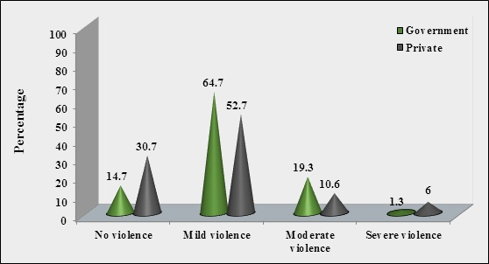
Fig 2: Percentage distribution of Government Nurses’ by perpetrators of Work Place Violence.
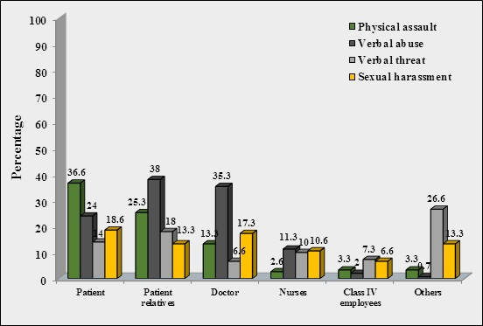
Fig 3: Percentage distribution of Private Nurses’ perpetrators of Work Place Violence.
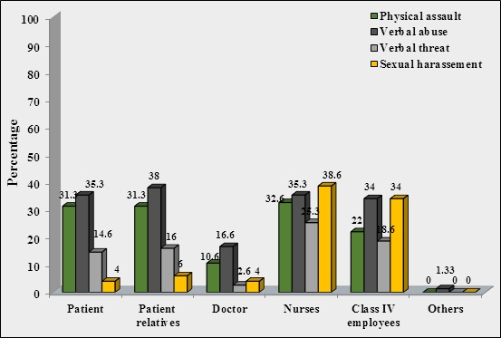
Fig 4: Percentage distribution of Nurses by emotional experiences after Work Place Violence.
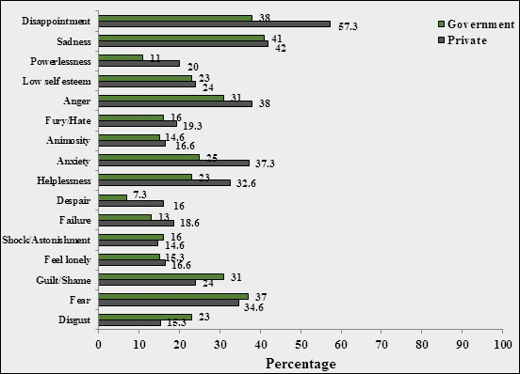
Fig 5: Percentage Distribution of Nurses by Coping Methods against Work Place Violence.
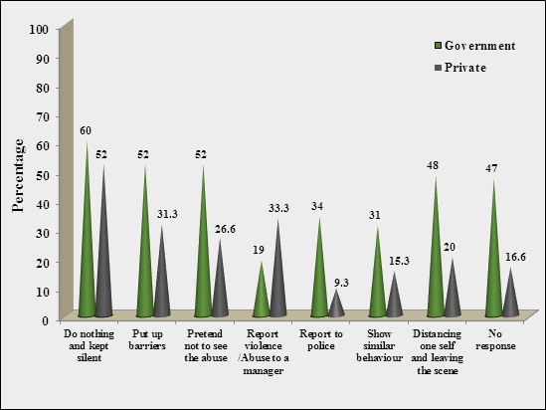
Fig 6: Percentage distribution of Nurses by actions taken after Work Place Violence.
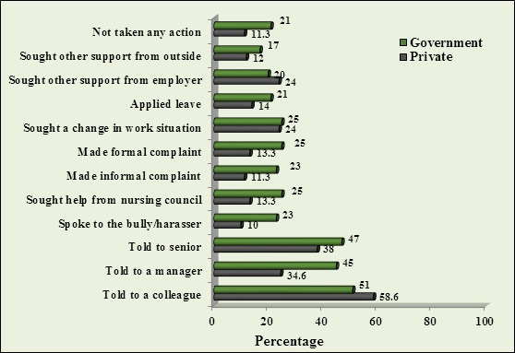
Fig 7: Percentage distribution of Nurses by response of the Employer against Work Place Violence.
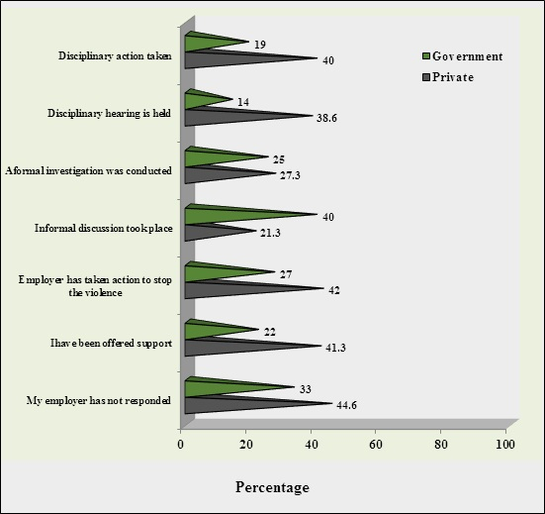

DISCUSSION:
This chapter deals with comparison of work place violence among Government and private nurses in selected hospitals. Work place violence is a problem plaguing more commonly among nurses who work in health care settings. Health care workers are exposed to a variety of factors that increases their risk for physical, verbal threat, sexual harassment more commonly in the form of work place violence from patient, patient relatives, doctors, nurses, managers and other people in the hospital. A survey was conducted by using self administered structured questionnaire to assess the work place violence among nurses.
In the current study majority of Government 97(64.7%) and private 79(52.7%) nurses experienced mild Work Place Violence. Work place violence is a major problem and almost all employees are exposed to some kind of work place violence [[8,9]. In nursing management’s 2008 survey, out of 1400 respondents 1337 expressed that they experienced some form of Violence in work setting [10]. An International survey (2008) reported that 73% of nurses experienced work place violence.
The most common perpetrator for Physical Assault in Government nurses was patients 55(36.6%). According to [11] supporting study, the physical assault 79.6% is more common in nurses. Whereas 49(32.6%) Private nurses experienced from nurses and 47(31.3%) were from patients and patient relatives. Study findings revealed that 90% of nurses experience lateral violence. The most common perpetrators for Verbal Abuse was patient relatives in both Government and private 57(38%) nurses, whereas for Verbal Threat 27(18%) of Government nurses from patient relatives and surprisingly from nurses 38(25.3%) in case of private nurses(12). The Sexual Violence was encountered by patients 28(18.6%) in Government nurses, whereas 58(38.6%) from nurses in private hospitals. There is no significant difference in the work place violence against respondent nurses p=0.12. So findings revealed that major perpetrators were patients and patient relatives in Government nurses against in private from nurses. Supporting to current study 26% of nurses experienced Physical Violence from patients (53.2%), colleagues (51.9%) estimated 90% of nurses experienced Verbal Abuse and 43% physical violence respectively the more lateral violence is seen among nurses may be due to the more time spent at work, female managers are not given opportunity in decision making, due to lack of leadership qualities. The violence from patients may be due to the illness and it can be considered as unintentional. Usually the patients and patient relatives become aggressive as a result of disease, depression they react as a self defense.
The most common emotions experienced after Work Place Violence was sadness 61(41%) disappointment 57(38%) and fear 55(37%) in Government nurses where as disappoint 86(57.3%), 63(42%) sadness and anger 57(38%) in private nurses. Supporting to the current study many nurses experienced fear, shock, being numb, terrified and scared, sleeplessness against Physical Assault whereas anxiety and aggression towards verbal abuse. Some nurses felt less empathy towards patient after violence, for some it has enhanced the confidence how to be cautious, some improved their abilities. The most common reactions experienced were sadness and anger.
Majority of Government 90(60%) and private nurses 78(52%) used do nothing and kept silent to cope with violence. Similar results were stated by getting support from others is another strategy used against negative effects of violence. Whereas 78(52%) and of Government nurses pretend not seen the abuse same number of people put up barriers against abuse. As reported that 27% victims of physical violence took no action and 49% attempted to defend themselves stepping away from the event.
Majority76(51%) and 88(58.6%) told to colleague followed by told to senior staff 70(47%), 57(38%) in Government and private nurses respectively. Third highest action taken was told to a manager 67(45%), 54(34.6%) in respondent nurses. In support to this study reported that 80% of respondents reported the incident to their colleagues and 56% of the reported to the senior staff.
Response of the employer against work place violence in private hospital 67(44.6%) of nurses expressed that there was no response. These results were supported by who reported that half of the nurses reported the formal hospital system against Abuses, Violence, as a reaction almost no action was taken. This made an angry reaction among nurses and either resigned or did nothing. In contrast to these results 41.3% of private nurses expressed that employer has been offered support, whereas 42% of them taken action to stop the violence. Whereas in Government this was only 22% and 27% respectively. In current study 58(38.6%) and 60(40%) of private nurse revealed that there was disciplinary hearing held and action was taken. In case of Government least number of nurses 21(14%) and 29(19%) of them said there was no proper response by employer, these result was in consistence with 36% nurses did not report the incidence due to the lack of effective action when staff suffered with abuse. It was concluded that an appropriate response by those in authority may be required to reduce on the job abuse against nurses.
Satisfaction of nurses with employer response, majority of private nurses 32(21.3%) has expressed situation was improved after employers action to stop the violence Where as in contrary to these results 15.3% of Government nurses said that without employer action situation was improved. After employer disciplinary action 42(28%) of private nurse said situation improved whereas 12(8%) of them expressed the situation remained same. To contrast these results study revealed 87.8% of the nurses reported that the follow up by hospital authority was un-satisfactory [12].
There was significant association between the age and type of violence (χ²=17.669, p=0.039) results revealed there was a significant relationship between age and violence, (p=0.001). It was concluded that, lesser the age more the violence. In present study income also associated with the type of violence with χ²=24.993 which was significant at p=0.015.
Whereas in private there was significant association with religion (χ²=22.189, p=0.008), educational level (χ²=25.751, p=0.002) having a bachelors degree or higher in nursing was associated with a decreased likelihood of reporting abuse.
Significant association was found with designation (χ²=34.517, p=0.011), type of employment (χ²=44.717, p=0.00) and experience (χ²=28.34, p=0.00). This reveals less education level, lower designation, temporarily employed nurses are more prone for Work Place Violence. As lateral violence is most commonly seen in this study senior nurses abuse the nurses who are temporary as they can’t restart against them, their subordinates who usually will be submissive. Less experience nurses fear more and they are prone for Work Place Violence when compared to experience nurses as they know how to handle the situation and what to do against violence at work place.

CONCLUSION:
The study concluded that both the respondent nurses experienced mild work place violence. The major perpetrators of work place violence were patient and patient relatives. It is because of the illness in the family they become aggressive and get depressed as the prognosis of the disease was in dilemma. The common emotions experienced by the nurses are sadness, anger and disappointment. The lateral violence and work place violence can be reduced by the development and implementation of specific policies, procedures and staff education programmes. Measures to protect the nurses includes the use of onsite security personnel’s, police officers, and surveillance cameras. Comprehensive work place violence prevention plans should be implemented and evaluated in every department.

REFERENCES
- Barbara, Kozier. (2002). Text book of fundamentals of nursing. London: Addision Wesley publications.
- Spector, PE., Zhou, ZE. (2013) Exposure to physical and non physical violence, bullying and sexual harassment. International Journal of Nursing students, 51(1), 72-84.
- Ando, S., Ono, Y., Shimaoka, M., Hiruta, S., Hattori, Y., Hori, F. & Takeuchi, Y. (2000) Associations of Self estimated workloads with Musculoskeletal Symptoms among Hospital Nurses. Journal of Occupational Environmental Medicine, 57, 211-216.
- Gerberich.,S.(2004) An epidemiological study of the magnitude and consequences of work related violence. The minnisota nurses study. Occupational and environmental medicine, 61, 495-503.
- Lee, H., Song, R., Cho, Y.S., Lee, G.Z. & Daly, B. (2003) A Comprehensive model for predicting burnout in Korean nurses. Journal of Advanced Nursing 44 (5), 534–545.
- Pellissier, G., Migueres, B. & Tarantola, A. (2006) Risk of needle stick injuries by injection pens. Journal on hospital infections, 63, 60-64.
- Badley, EM., Rasooly, I & Webster, GK. (1994) Relative Importance of Musculoskeletal Problems as a Cause of Chronic Health Problems and Disability. Journal of Rheumatology, 21(3), 505-514.
- Burdorf, A & Sorack, G. (1997) Positive and Negative Evidence of Risk Factors for Back Disorders. Scandinavian Journal of Work, Environment and Health, 23 (4), 243-256.
- Hoeve, Y T., Jansen, G., & Roodbol, P. (2013) The nursing profession: public image, self concept and professional identity. Journal of Advanced Nursing, 70 (2), 295-309.
- Alexopoulos, E.C., Burdorf, A & Kalokerinou, A. (2003) Risk Factors for Musculoskeletal Problems among Nursing Personnel in Greek Hospital. Journal of International Archives of Occupational and Environmental Health, 76 (4), 289-294.
- Janssen, PP., Jonge, JD & Bakker, AB. (1999) Specific determinants of intrinsic work motivation, burnout and turnover intentions. Journal of Advanced Nursing, 29, 1360-1369.
- Khan., Muhammad, Khalid., Rizwan, Qaiser; Munir., Yasin., Hafeez., Saida, Alam., Noureen., Fatima. & Arooj. (2013) Association of stress knowledge management and change with organizational effectiveness in education sector of Pakistan.

