e - ISSN – 2349-0683

 | Asian Pacific Journal of Nursing | 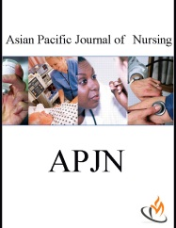
 | Journal homepage: www.mcmed.us/journal/apjn

P.M.S. [Performance Management System]

Usha Banerjee^{1*}, Jiji Dias², Hemlata³, N.Rathina⁴

¹Group Director of Nursing, Apollo Group of Hospitals. Indraprastha Apollo Hospital, New Delhi-76, India.
²Assistant Nursing Superintendent Nursing Education and Development, Indraprastha Apollo Hospital, New Delhi-76, India.
³Nursing Supervisor, Indraprastha Apollo Hospital, New Delhi-76, India.
⁴Senior Learning Officer, Indraprastha Apollo Hospital, New Delhi-76, India.

ABSTRACT
Performance management is a process of aligning an organisation’s goals with the employee goals. It is an on-going and interactive process that helps the employee enhance their capability and facilitate productivity, there -by employee’s work behaviour is aligned with organisational goals. P.M.S. is an organised set of activities established to regularly and systematically evaluate employee performance and ensure its alignment to business metrics. Organisation also link it to rewards and incentives. P.M.S. includes, planning, monitoring, developing, rating and rewarding. Workforce dynamics are changing, driven by far-reaching trends like ethnic and age diversity, global competition for limited talent, unprecedented pressures on managers, and the growing use of contingent personnel. Corporate business management platform provides and translates insights into the complete picture. A 360 degree appraisal is a type of employee performance review in which subordinates, co-workers and managers all anonymously rate the employee. This information is then incorporated into that person's performance review. Human resource is vital for any organization it is one of the useful resources. If human resource or employees of any organization will be happy, they will do their best in organization and vice versa. Nursing staff are one of most valuable asset of the hospital. P.M.S. is a transparent structured timely approach to appraisal of our staff.

Key words: P.M.S.[ Performance Management System.] , planning, monitoring, developing, rating , rewarding, appraisal.

Corresponding Author  Usha Banerjee  Email:- usha_b@apollohospitalsdelhi.com | Article Info  Received 18/08/2016; Revised 20/08/2016  Accepted 24/08/2016

INTRODUCTION
Human resource refers to the talents and energies of people that are available to an organization as potential contributors to the creation and realization of the organizations’ mission, vision, values, and goals. Development refers to a process of active learning from experience-leading to systematic and purposeful development of the whole person, body, mind and spirit.
Indraprastha Apollo Hospital is a quaternary care hospital with a complex set up covering various super specialties with 700 beds. We have approximately 1400 nursing staff and they are one of most valuable asset of the hospital. Staff performance should be as par with the organization mission and objectives. In nursing fraternity across the country there is no transparent structured timely

approach to appraisal.
In a 360 degree appraisal[1] a staff member's work for a specific period of time, often a year, is discussed and critiqued by other employees. The 360 degree process is different , it obtains feedback from co-workers and subordinates instead of just from the direct supervisor. The goal of the process is to understand how the employee is functioning as part of the team and to improve the ways team members work together
It may be possible to get all employees to reconcile personal goals with organizational goals and increase productivity and profitability of an organization using this process.[2] It can be applied by organizations or a single department or section inside an organization, as

well as an individual person
Werner Erhard, Michael C. Jensen, and their colleagues have developed a new approach to improving performance in organizations. Their model stresses how the constraints imposed by one’s own worldview can impede cognitive abilities that would otherwise be available. Their work delves into the source of performance, which is not accessible by mere linear cause-and-effect analysis. They assert that the level of performance that people achieve correlates with how work situations occur to them and that language (including what is said and unsaid in conversations) plays a major role in how situations occur to the performer. They assert that substantial gains in performance are more likely to be achieved by management understanding how employees perceive the world and then encouraging and implementing changes that make sense to employees' worldview.[3]
In public sector, the effects of performance management systems have differed from positive to negative, suggesting that differences in the characteristics of performance management systems and the contexts into which they are implemented play an important role to the success or failure of performance management [4-5].

Need for performance appraisals
•Our staff performance system was non-transparent and appraisals were confidential
•Earlier to this the appraisals were non structured
•Previous to this, appraise didn’t know the appraisal criteria as it was a Closed review system
•Not goal oriented
•No system of data collection and analysis was there to access an employee
•Lack of error tracking mechanism to substantiate marks
•Employee was not allowed to question to higher authority for their appraisals
•Non incentivizing for specialized teams
•Lack of tools to identify training needs
•Non availability of dashboards to monitor their clinical skills and progress
•No opportunity to link individual and unit performance to appraise
•No link between staff performance and their career growth
•Lack of opportunities for periodic quarterly review
•Appraisals were subjective & non objective and was not measurable
•There was no link between Quality indicator and appraisals
•Appraisals are depend upon the year of experience based not on staff potential based

Method of staff appraisal
A transparent, structured, 360 degree performance management system with the goal to
- Create a transparent and fair performance management process that builds engagement and trust
- Build a corporate culture that embraces high performance and corporate key values
- Link employee performance directly to corporate goals
- Allow managers more face-to-face time with employees, increasing engagement.

Benefits of PMS for patients and staff that has been achieved in our organization
Parameter | Description of Benefit
Impact on Employees | - Created impact of empowerment  - Continues mechanism to track training need  - No grievance in appraisal  - Periodically apprised staff on deviation  - Career progression  - Staff satisfaction- increased voice of employee (VOE) as system is transparent and 360 degree appraisal  - Increased staff retention refer to (Figure –2)  - Reduced staff grievances and dissatisfaction due to regular feedback refer to (Figure –3)  - Increased staff accountability  - Staff get opportunity for feedback  - Specialized team for IV safety, prevention of pressure ulcers, lactation initiation, discharge process, infection control, pain management  - Career growth- in-service education like XLRI management course, 6 sigma, Leadership development programme, Ward sister course, Post graduate diplomas etc.  - Staff development- staff get promoted as an acting charge nurse for 6 month and designated as charge nurse if competent in performance  - Incentives for specialized team
Impact on Patients | - Voice of customer-patient satisfaction has increased drastically refer to (Figure –4)  - Less incidents –medication error refer to (Figure –4.1), patient fall, needle stick injury etc.  - Patient complaints reduced refer to (Figure –4.2)
Impact on Environment | - Culture of esprit de corps (team spirit)  - People connect programme- birthday celebrations
Impact on Finance | Cost reduction and elimination of waste(CREW)-less attrition rate, reduced cost for recruitment  Material management
Innovation and Change | - Award winner for HMA[ Hospital Management Asia] and AIQA Apollo Innovative Quality Award] Figure .6
Impact on Community Services | - Visit beyond the duty hours to Akashaparavakal - Friends of the Birds of the Air on Holy week  - Delhi Cherish home on Onam festival  - Health Camp for community Health Check

Satisfied staff provides satisfied services to patients. Figure .5
Appraisals are transparent, objective and based on performance of the staff
Increased staff retention
• Staff grievances reduced to zero
• 100% job satisfaction
• Improved patient satisfaction
• No medication administration error
• Less patient complaints
• Specialized services in Nursing department
- Intra venous (IV)safety team : For painless IV cannulation
- Pain management team: For managing patient pain specially after surgery
- Transport team: For shifting of patients from ward to operation theatre and vice versa
- Quick resuscitation team (QRT): For managing emergency situations without delay
- Hospital acquired pressure ulcer team(HAPU): To bring down incidences of pressure ulcers to zero in patients
- Clinical cabinet team: To maintain compliance on quality and to do innovation projects
- Lactation nurse: To initiate breast feeding in mothers
- Discharge team: To speed up the discharge process
- Infection control team: To maintain compliance on infection control practices

Training program that are planned to enhance staff performance
All the nursing staffs at Apollo hospital are part of this project.
Performance management practices can have a positive influence on the job satisfaction and employee loyalty by
increased employee engagement and foster a higher-
performance culture
- Clarifying job responsibilities and expectations
- Enhanced individual and group productivity
- Improved communication between employees and manager
- Evaluating performance and distributing incentives and rewards on a fair and equated basis
- Recognizing and rewarding good performance in an organization
- Providing maximum opportunities for career growth.

DISCUSSION AND CONCLUSION
Performance management system and performance rating is an important step to measure work which the analyst observes the worker's performance and records a value representing that performance relative to the analyst's concept of standard performance.
Performance rating helps people to do their jobs better, identifies training and education needs, assigns people to work, they can excel in, and maintains fairness in salaries, benefits, promotion, hiring and firing. Most workers want to know how they are doing on the job. Workers need performance feedback to work effectively. Accessing an employee timely, accurately, constructive feedback is key to effective performance Motivational strategies such as goal setting depend upon regular performance updates. There are several methods of performance rating. The simplest and most common method is based on speed or pace. Standard performance is denoted as 100%.A performance rating greater than 100% means the worker's performance is more than standard, and less than 100% means the worker's performance is less than standard. Our appraisal methods has rewarded us with best staff performance and satisfied working environment.

Figure 1. Performance Management System (PMS)-Nursing  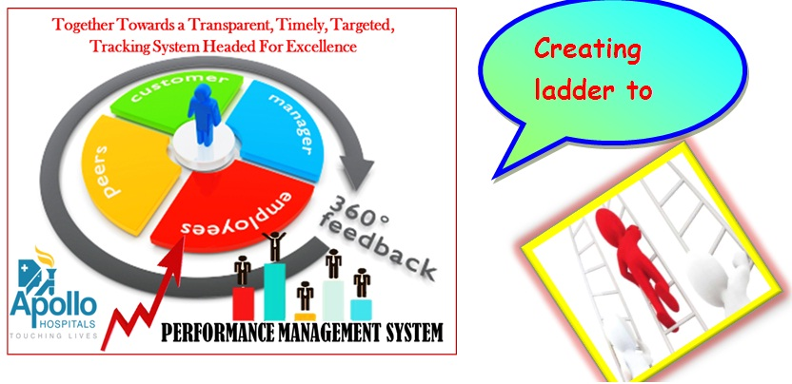 | Figure 2.  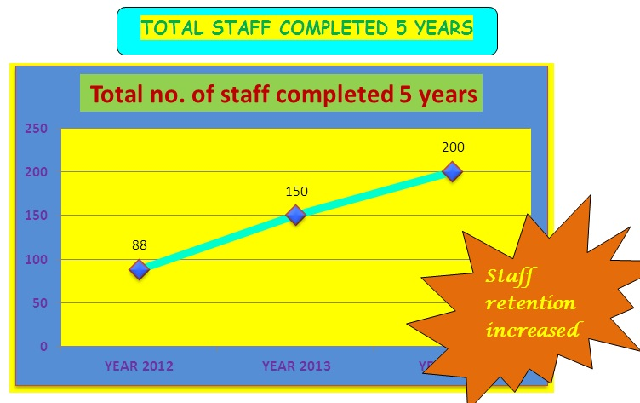
Figure 3.  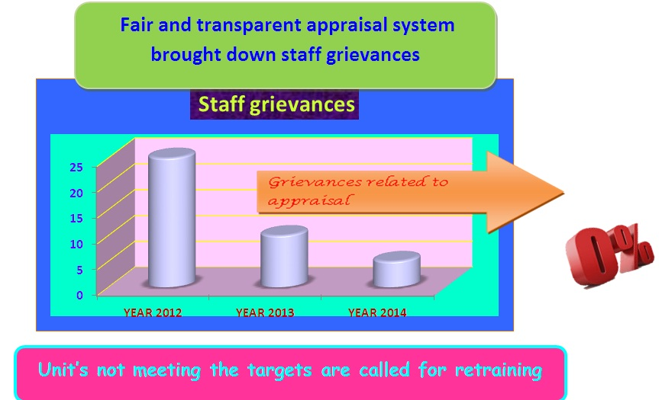 | Figure 4.Voice of customer (VOC): Patient satisfaction is one of the crucial indicators for staff performance. VOC forms are collected on daily basis and analyzed and reported weekly  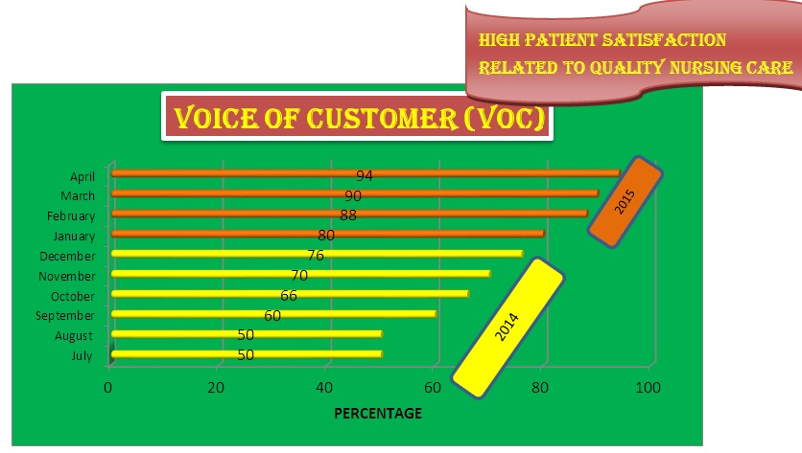
Figure 4.1.  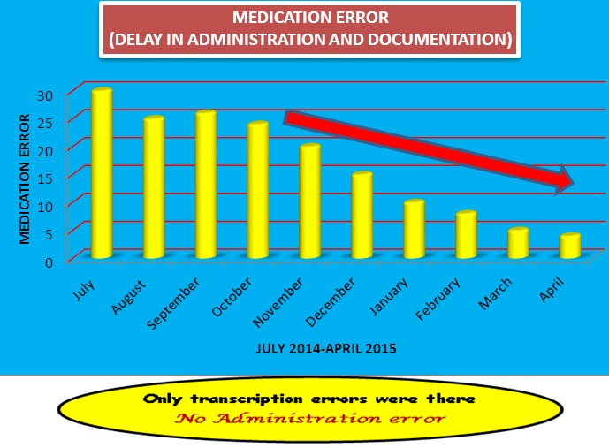 | Figure 4.2.  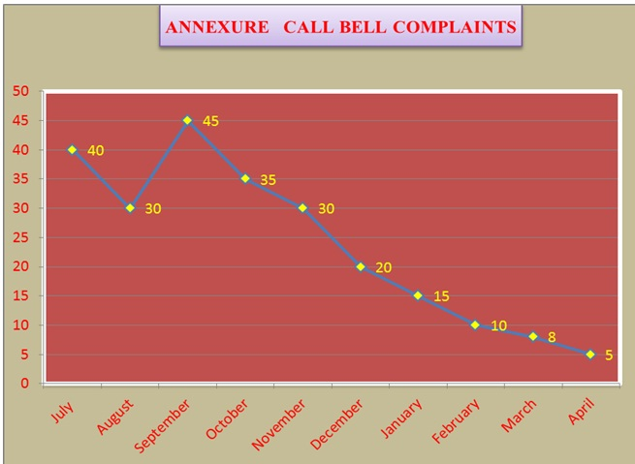
Figure 5.  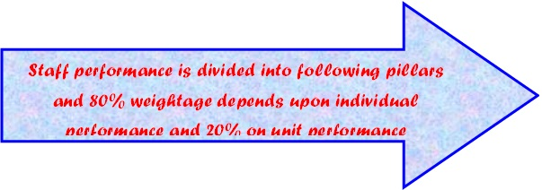 | Figure 6.  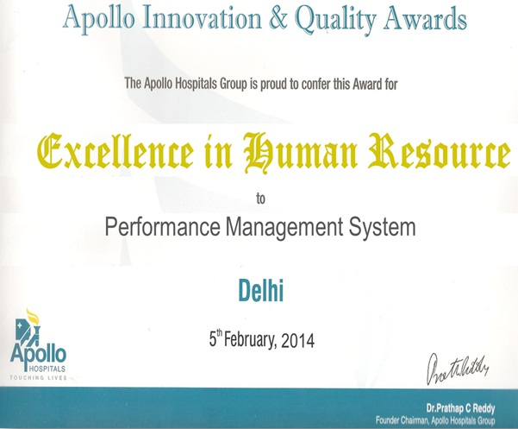
  S. no. | Pillar | Measures
  1 | Clinical excellence | Patient fall, medication error, pressure ulcer etc.
  2 | Operational excellence | Voice of customer, physician complaints, patient complaints etc.
  3 | People | Training targets
  4 | Finance | Cost reduction and elimination of waste (CREW)
  5 | Quality | Tracer compliance/daily audits
  6 | COE[center of excellence] | Cardiology ,Orthopedic ,Neurology , Emergency, Oncology and Transplant
  7 | VOC[ voice of customer] | Weekly VOC rating for every unit
  8 | Feedback | Consultant, Peer group etc.
  9 | Departmental feedback | Key performance indicator for each unit
  10 | Service excellence | Communication skills, grooming etc.
  11 | Discipline | Absenteeism, punctuality etc.
  12 | Awards and accolades | Star employee, learning initiative in conferences and conclaves
  13 | Extra-curricular activities | Involvement in sports, cultural programmes etc.
  And many more ……

REFERENCES
- Greguras GJ & Robie C. (1998). A new look at within-source inter rater reliability of 360-degree feedback ratings. Journal of Applied Psychology, 83, 960–968.
- Nielsen Poul A. 2013. Performance Management, Managerial Authority, and Public Service Performance. Journal of Public Administration Research and Theory. Published electronically on June 2. doi:10.1093/jopart/mut025.
- Madden, Bartley J. (2014). Reconstructing Your Worldview. Learning What Works Inc. p. 99. ISBN 0988596938
- Jump up ^ Swiss, James E. (2005). A framework for assessing incentives in results-based management. Public Administration Review, 65, 592–602.
- Mettler T, Rohner P (2009). Performance management in health care: The past, the present, and the future (PDF). International Conference Business Informatics. Vienna. pp. 699–708.

